For every operation like file open , save, rename, save etc The smb client sends requests to EBS server. In my tests the smb client was windows xp's network neighborhood.

The best approach to get an understanding of what is going on (like for any operation, what are the requests that the client is sending to the server) is to OPEN UP a packet capture utility (I use packetyzer which is free and is based on ethereal .Ethereal should be fine too). The good thing about a packet capture is that smb requests and responses are decoded in human readable form and this gives us a clear idea of the request that was send and the response that was send by the server.

I am attaching a screenshot to explain of what I mean. Do not try to look at actual bits that are transferred between server and client as it will not make sense but look at the packet summary of the packet capture utility. Look at the attached file 'packet capture example.jpg' and you will understand what I mean.

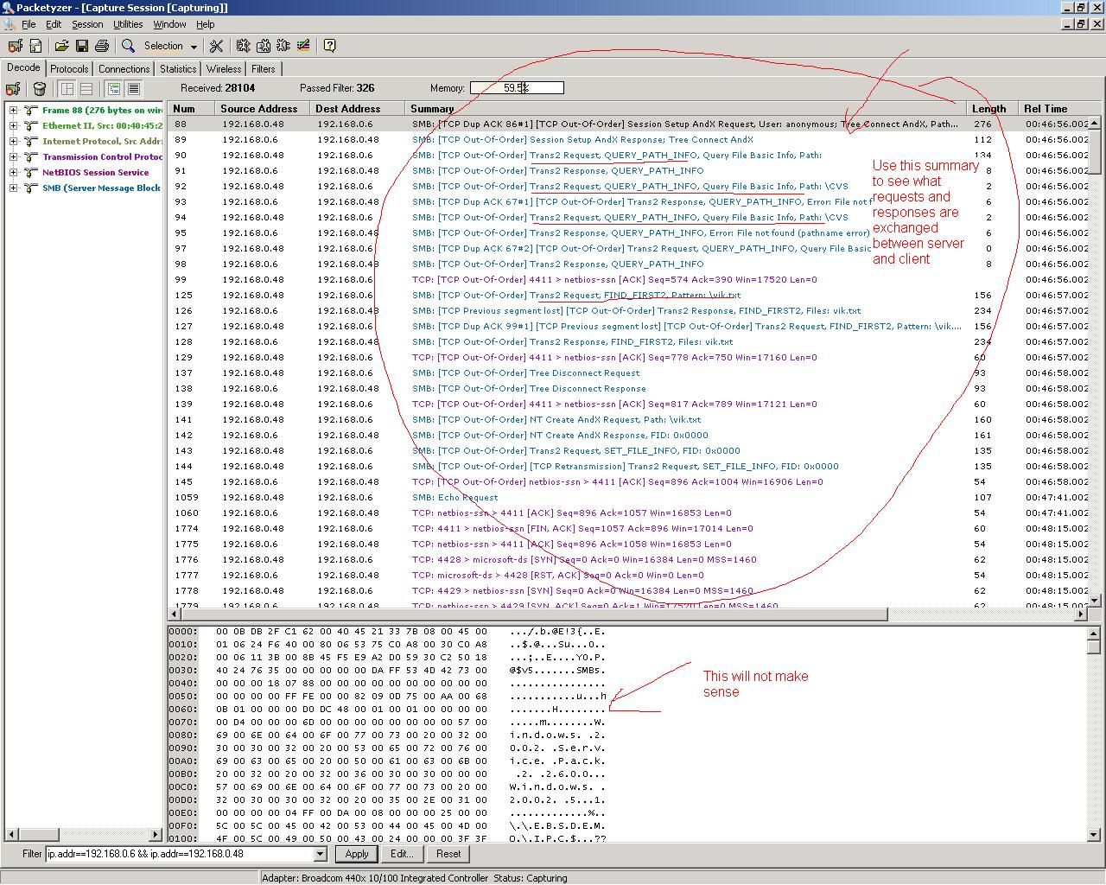

Next, see what is happening for each operation, you will notice that there are different categories of commands requests that the client sends to server for any operation. For example ANDX type, Trans2 type, Set Session, rename, etc. the server waits in a while loop to receive these commands and process them one at a time and sends response for each request.

For every operation, client sends out one request at a time to the server, all these requests are needed to perform this one operation. The server receives these requests and sends out responses to each.

An example of requests sent by the client to the server in my tests for rename and delete commands is attached in file 'understanding server.txt'.

Command Request Type Request Category Request

Rename
Trans2 Query Path Info Query File Basic Info
Trans2 Find_First2
Trans2 Query Path Info Query File Basic Info
Trans2 Query FS Info Query FS Attribute Info
Trans2 Find_First2
Trans2 Query FS Info Query FS Attribute Info
Create ANDx
Trans2 Query File Info Query File Basic Info
Trans2 Query Path Info Query File Basic Info
Trans2 Find_First2
Create ANDx
Trans2 Query File Info Query File Basic Info
Trans2 SET File Info
Trans2 Query File Info Query File Standard Info
Read ANDx
""
..
..
""
Trans2 Query File Info Query File Standard Info
Read ANDx
Trans2 Query File Info Query File Standard Info
Read ANDx
Read ANDx
Read ANDx
Trans2 Query File Info Query File Standard Info
Trans2 Query File Info Query File Standard Info
Read ANDx
""
..
..
""
Trans2 Query File Info Query File Standard Info
Trans2 Query File Info Query File Standard Info
Close
---------
Create ANDx
Trans2 Query File Info Query File Basic Info
Close
Close
Rename
Trans2 Query Path Info Query File Basic Info
Trans2 Find_First2
Trans2 Find_First2
Trans2 Find_First2
Session Setup ANDx
Trans2 Query Path Info Query File Basic Info
Trans2 Query Path Info Query File Basic Info
Tree Disconnect
_______________________________________________________________________

Command Request Type Request Category Request

DELETE
Trans2 Query Path Info Query File Basic Info
Trans2 Find_First2
Trans2 Find_First2

Create ANDx

SET FILE INFO ------------------------------>>>>>>>>>> NOT SUPPORTED

Close
Trans2 Query Path Info Query File Basic Info

Notice that the rename command was successful because the server responded successfully to each of client’s request. But for 'Delete" command the server returned an error for 'SET FILE INFO' request. So the solution in this case is simple, if we make this command work, i.e. if the server does not return an error for this command then delete will be successful.

Next, let us see what happens when a request comes to the server, the request goes to function SMBS_ProcSMBBody ( ) in file srvssn.c. This function is responsible for processing the message body of a request. Depending on type of request this function calls respective request handlers. (You will find a case statement and cases to handle different types of messages like NEGOTIATE, NT_CREATE_ANDX, READ_ANDX, and TRANSACTION2 etc.).

Since this message was a trans2 type, SMBS_ProcSMBBody ( ) invokes function ProcTransaction2 ( ) to handle this type of request. Now, this function is responsible for processing all trans2 type of requests. You will find that again there can be different kind of trans2 requests and this function has cases to handle each of them. For delete command discusses above, client request ''SET FILE INFO'' is of type TRANS2_SET_FILE_INFORMATION so this function invokes function ST2_SetFileInformation ( ) to handle this command.

Function ST2_SetFileInformation ( ) in file srvTran2.c is responsible for handling all ''SET FILE INFO'' type of commands, in our case for 'Delete' command the client passes 'SMB_SET_FILE_DISPOSITION_INFO' (value 102) as the command parameter. But you will notice that this case is not present in this function. (Cases SMB_INFO_STANDARD, SMB_SET_FILE_BASIC_INFO, SMB_SET_FILE_ALLOCATION_INFO etc are present)

Implementing This Case:
To experiment with this case, I added this case 'SMB_SET_FILE_DISPOSITION_INFO' with just a break

case SMB_SET_FILE_ALLOCATION_INFO: /* silently ignore this level of detail
since the file sys doesn't care and we don't need to send an error. */
break;
case SMB_SET_FILE_DISPOSITION_INFO:
break;

Putting this case here results in server no more sending a "command not supported" error message to the client. The client thinks that the delete command was successful and it removes the file from its local folder, (later on the file will reappear when the client refreshes the server information because the file is actually present on the server).

So the actual solution is to implement a function here which will delete the file from server's local file system. There are 2 ways, for this case implement a function which calls ProcDelete ( ) in file srvssn.c or directly call SMBFIO_Delete ( ) to delete the file on the server. If the file is no longer on the server the client will delete the file locally and the file will not reappear upon refresh.

Apply the same case to SMB_SET_FILE_END_OF_FILE_INFO. Also, I was able to rewrite the files on EBS server using windows XP client, this feature is already supported.

